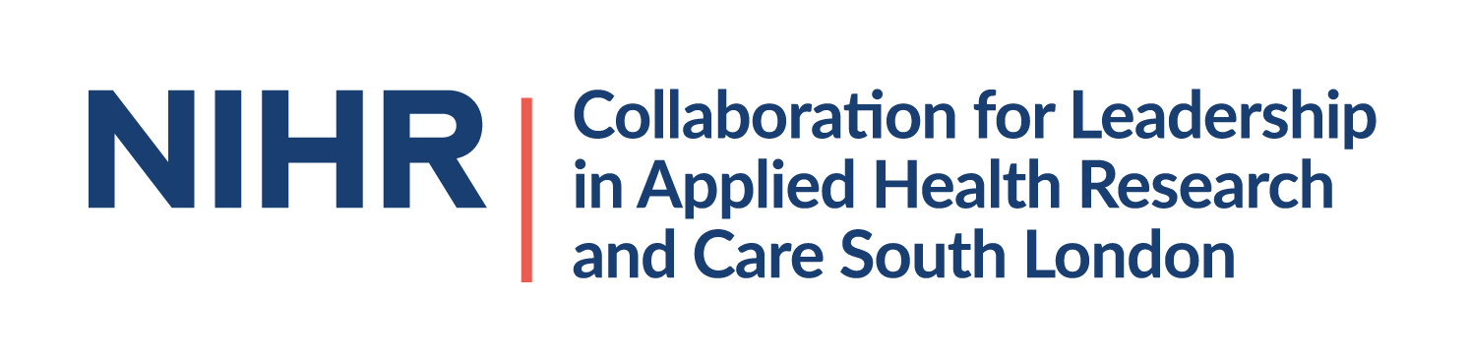
MHIN Lived experience advisory board member
We are inviting expressions of interest from people with lived experience of mental health challenges to join the Mental Health Implementation Network (MHIN) Advisory Board. The NIHR Applied Research Collaboration (ARC) National Priorities Programme in mental health was set up in October 2020 to support national collaborations and changes in mental health practice
The MHIN programme aims to evaluate the co-produced, evidence-based mental health interventions, to improve the wellbeing of adults, children and young people in in England. There will be a strong focus on public and community involvement.
We are looking to identify solutions for four priority projects that we have listed below. These solutions can then be implemented for each of the four priority projects in the next phase of our work which starts in 2022.
- Improving Access to Psychological Therapies (IAPT)-style services for children and adolescents, especially in schools
- Physical health care for people with severe mental illnesses
- Community access and engagement for minority ethnic communities for mental healthcare
- Integrated care protocols for co-occurring mental illness and substance misuse.

The MHIN Advisory Board meets quarterly. Board members may be asked to contribute and comment on papers in advance of meetings which will be held online. The role includes:
- Providing guidance on the development and implementation of the MHIN programme
- Act as a source of advice
- Provide reflection and learning to the MHIN
- Provide feedback on the direction of the MHIN and how the MHIN is delivering against its strategy
- Research specific issues and to feed back to the MHIN Executive as discussed and agreed
- Identify stakeholders and develop relationships and networks.
Advisory Board members will receive £125 for attending each of the four meetings annually (£500 per year to include preparation for meetings).
Skills and attributes required:
- Lived experience of mental health challenges
- Experience of attending national level meetings or leading on a national piece of work relating to health and wellbeing
- Confident in meetings with influential people
- Understanding of the mental health landscape within England
We encourage applications from the areas in the country where there are underserved populations, such as in the north of England.

Benefits of attending MHIN Advisory Board meetings include:
- The chance to work in a group with leaders in the field of mental health and research
- An opportunity to learn more about research
- Enhanced CV
- Using lived experience to bring about positive change
If you would like to contribute the MHIN Advisory Board please submit the one page expression of interest form to Flavia Bertini (flavia.bertini@kcl.ac.uk), below. Your statement should include skills you have gained at a national level through professional and voluntary work, and how you have used your experience of mental health challenges to influence change.
We will be in touch to discuss next steps. In order to inform this work in different areas of the country it would be helpful if you could state where you are based in England.
Support will be provided as required. Please also let us know about any accessibility requirements.

Indicative meeting dates for 2022:
- Thursday 17th March – 14.00-15.30
- Wednesday 22nd June – 10.00-11.30
- Wednesday 21st September – 14.00-15.30
- Tuesday 13th December – 11.00-12.30

Further opportunities
There will almost certainly be a range of opportunities with the MHIN as the programme expands. If you do not have enough experience for this role but you would like to register your interest for future involvement activities, do send your contact details to Flavia Bertini.
Expression of interest form:
Full name:
Email Address:
Preferred telephone number (Optional):
Geographical area e.g. North East

